**Question 1:**

*Track a journey using one of the installed mobile apps.*

**Question 2:**

*Open a browser on your computer and go to http://utrack.crempa.net/ Upload your GPX file to the site and click ‘Generate Report’. Take a screenshot and include here*

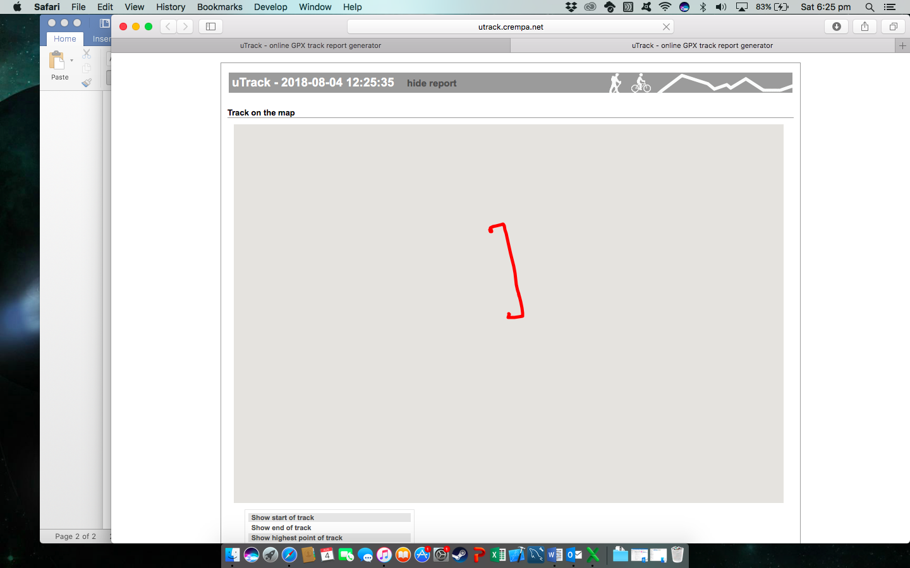

**Question 3:**

*What information can you see from the generated report?*

Information that can be found in the generated report include;

* Date
* Start Time
* End Time
* Various Speeds (Min, Max, Avg)
* Distance Traveled
* Elevations